Fourier Series Analysis via Oscilloscope

**Name: Christ-Brian Amedjonekou**

**Date: 3/18/2019**

**TCET 3102-E316 (Analog and Digital Com) Lab 2**

**Spring 2019, Section: E316, Code: 37251**

**Instructor: Song Tang**

**Members: ________________________________**

**________________________________**

# Table of Contents

1. Objective ........................................................................................ 3
2. Equipment ...................................................................................... 3
3. Theory ............................................................................................ 4
4. Results & Analysis ................................................................... 5 – 11
5. Conclusion .....................................................................................12

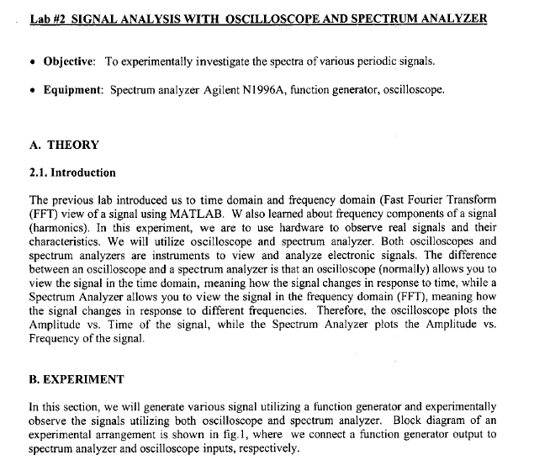

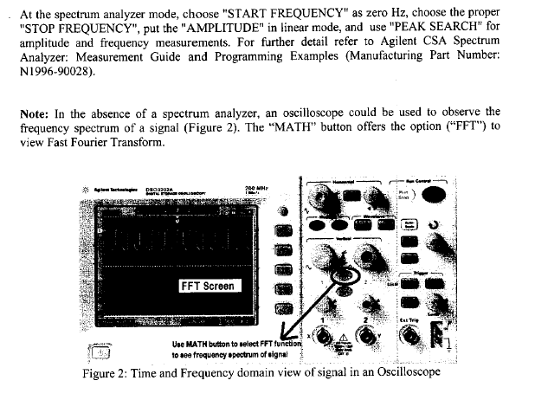

# Run 1:

* Generate a sinusoidal signal with a frequency of $100 KHz$ and the amplitude of $2 V$. Observe the waveforms on the oscilloscope screen. Vary the Frequency and Amplitude slightly.
* Observe its spectrum on the spectrum analyzer screen.
* Vary the Frequency and observe the effect.
* Vary the Frequency and observe the effect. Show all figures and explain in the lab report

# Run 1 Part 1:

* We set the frequency to $100 KHz$ and the amplitude of $2 V$. So, for the Spectrum, we end up seeing one spike with a magnitude of $100 KHz$.

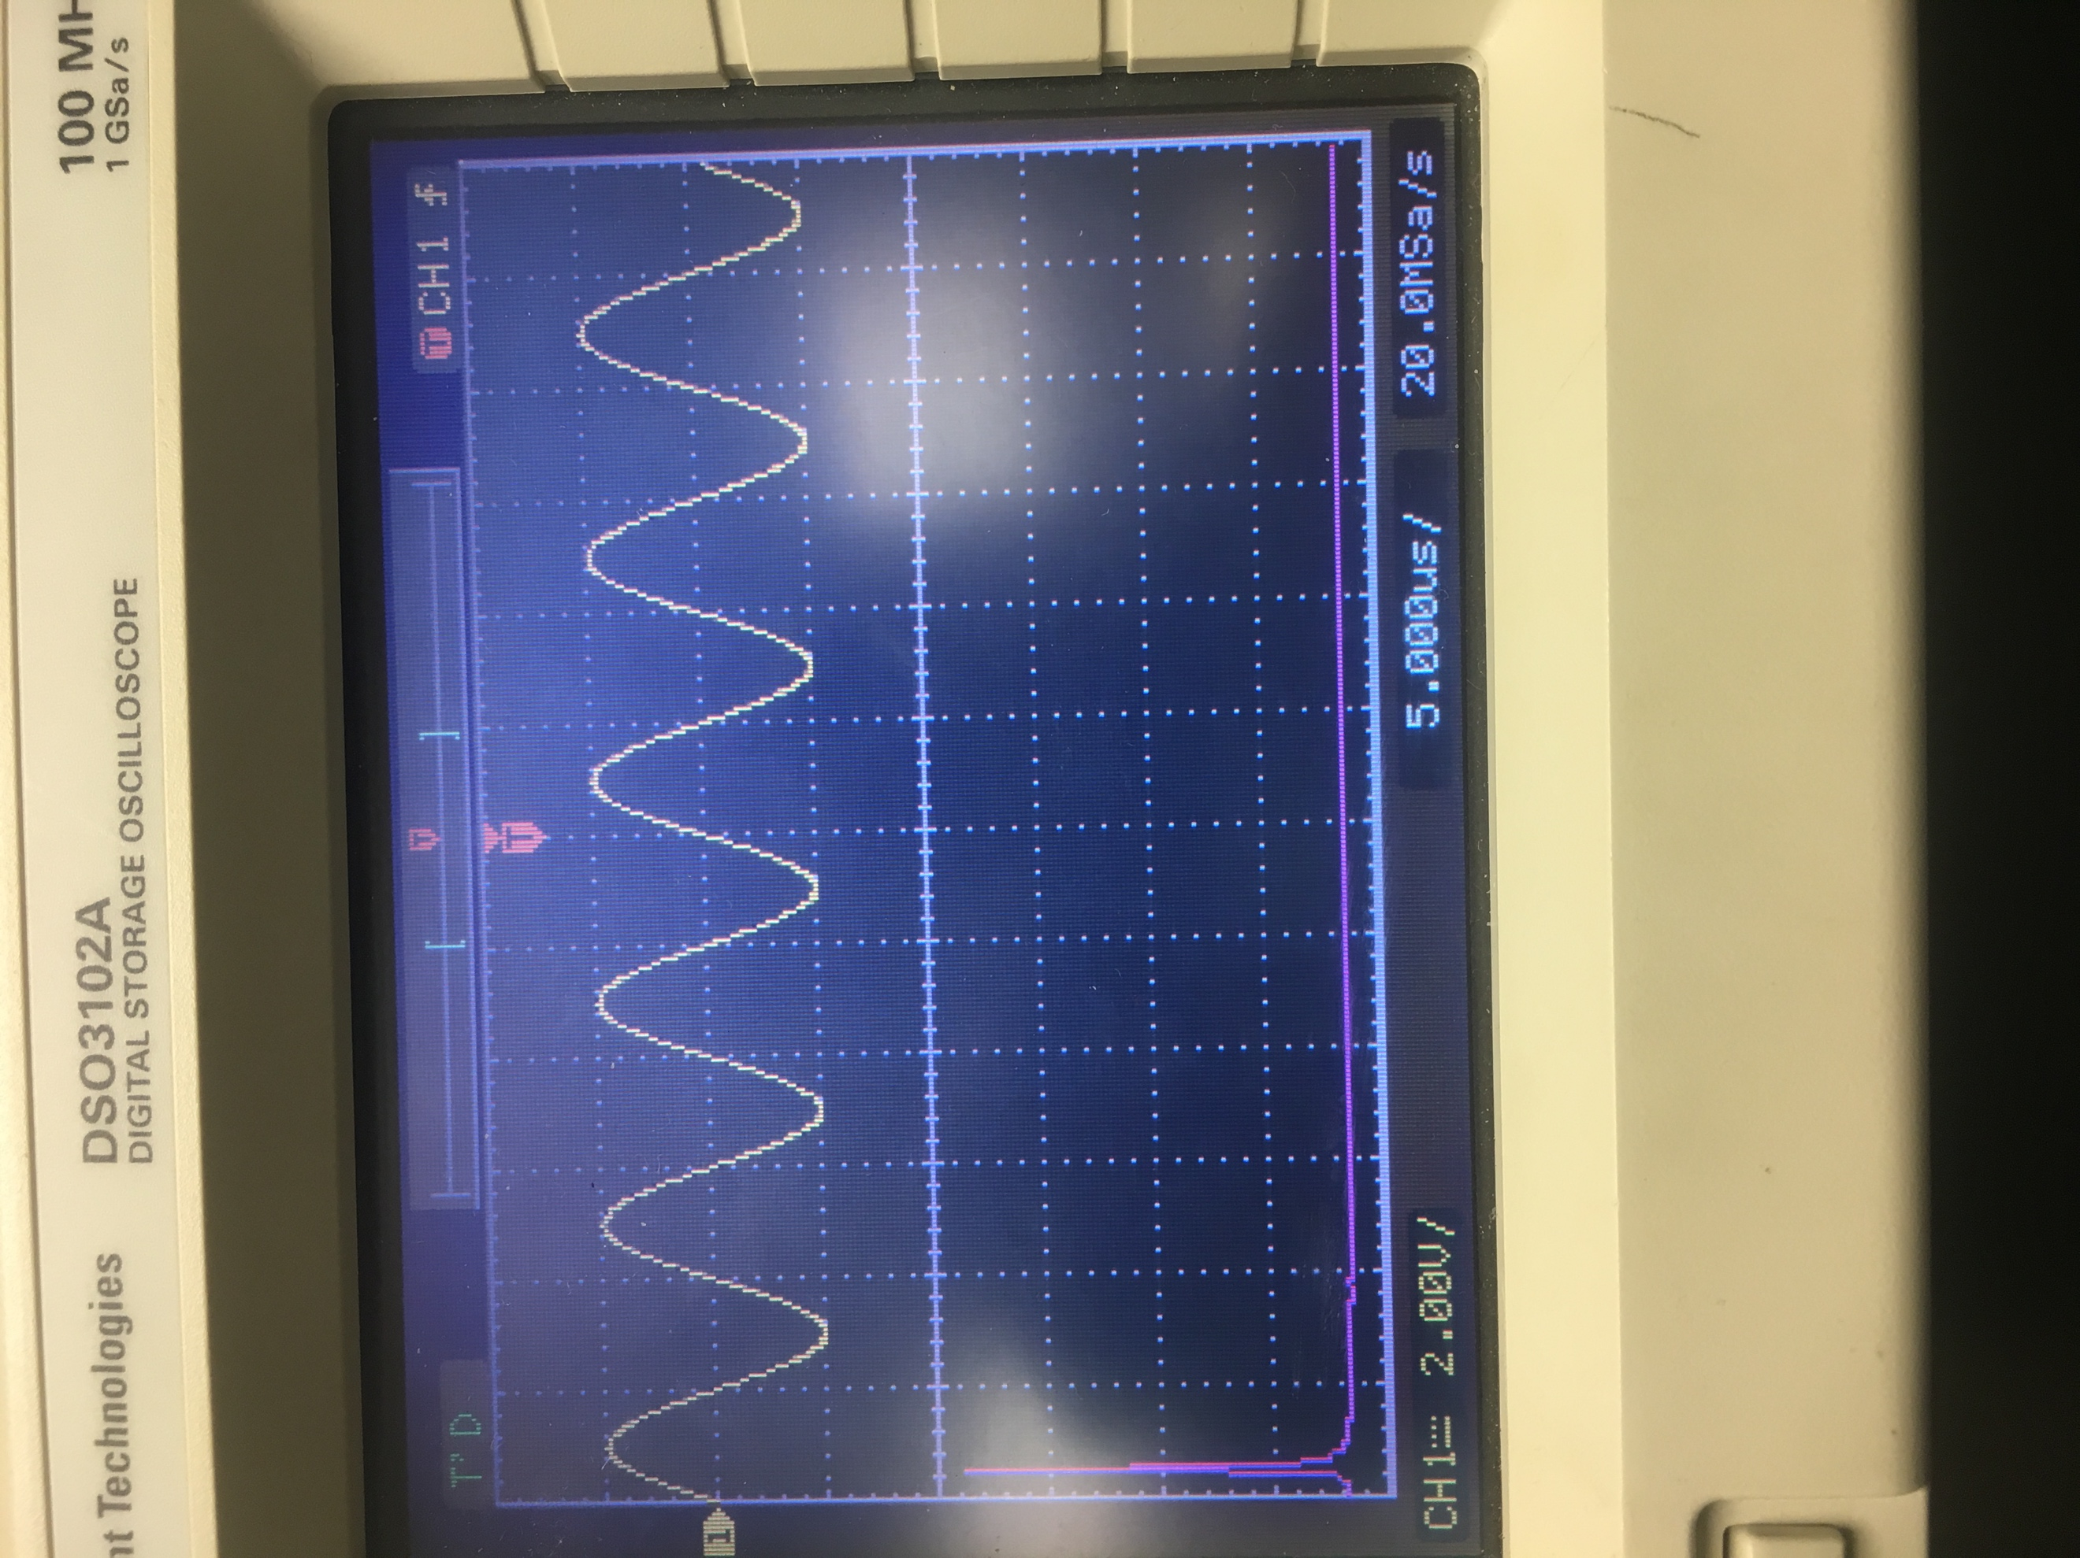

# Run 1 Part 2:

* We set the frequency to $75 KHz$ and the amplitude of $2 V$. So, for the Spectrum, we end up seeing one spike with a magnitude of $75 KHz$.

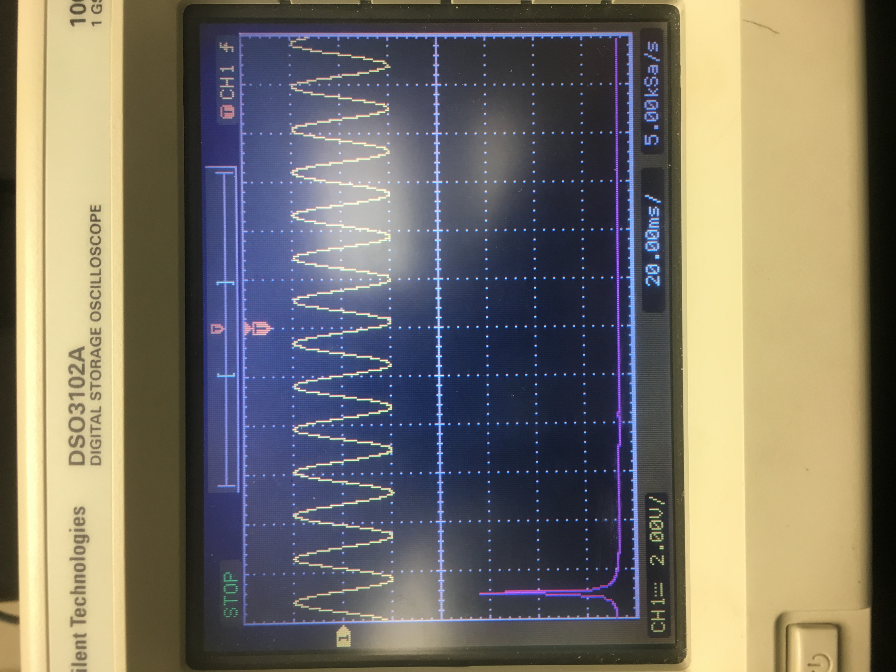

# Run 1 Part 3:

* We set the frequency to $100 KHz$ and the amplitude of $4 V$. So, for the Spectrum, we end up seeing one spike with a magnitude of $100 KHz$. Nothing really changed with the spectrum here.

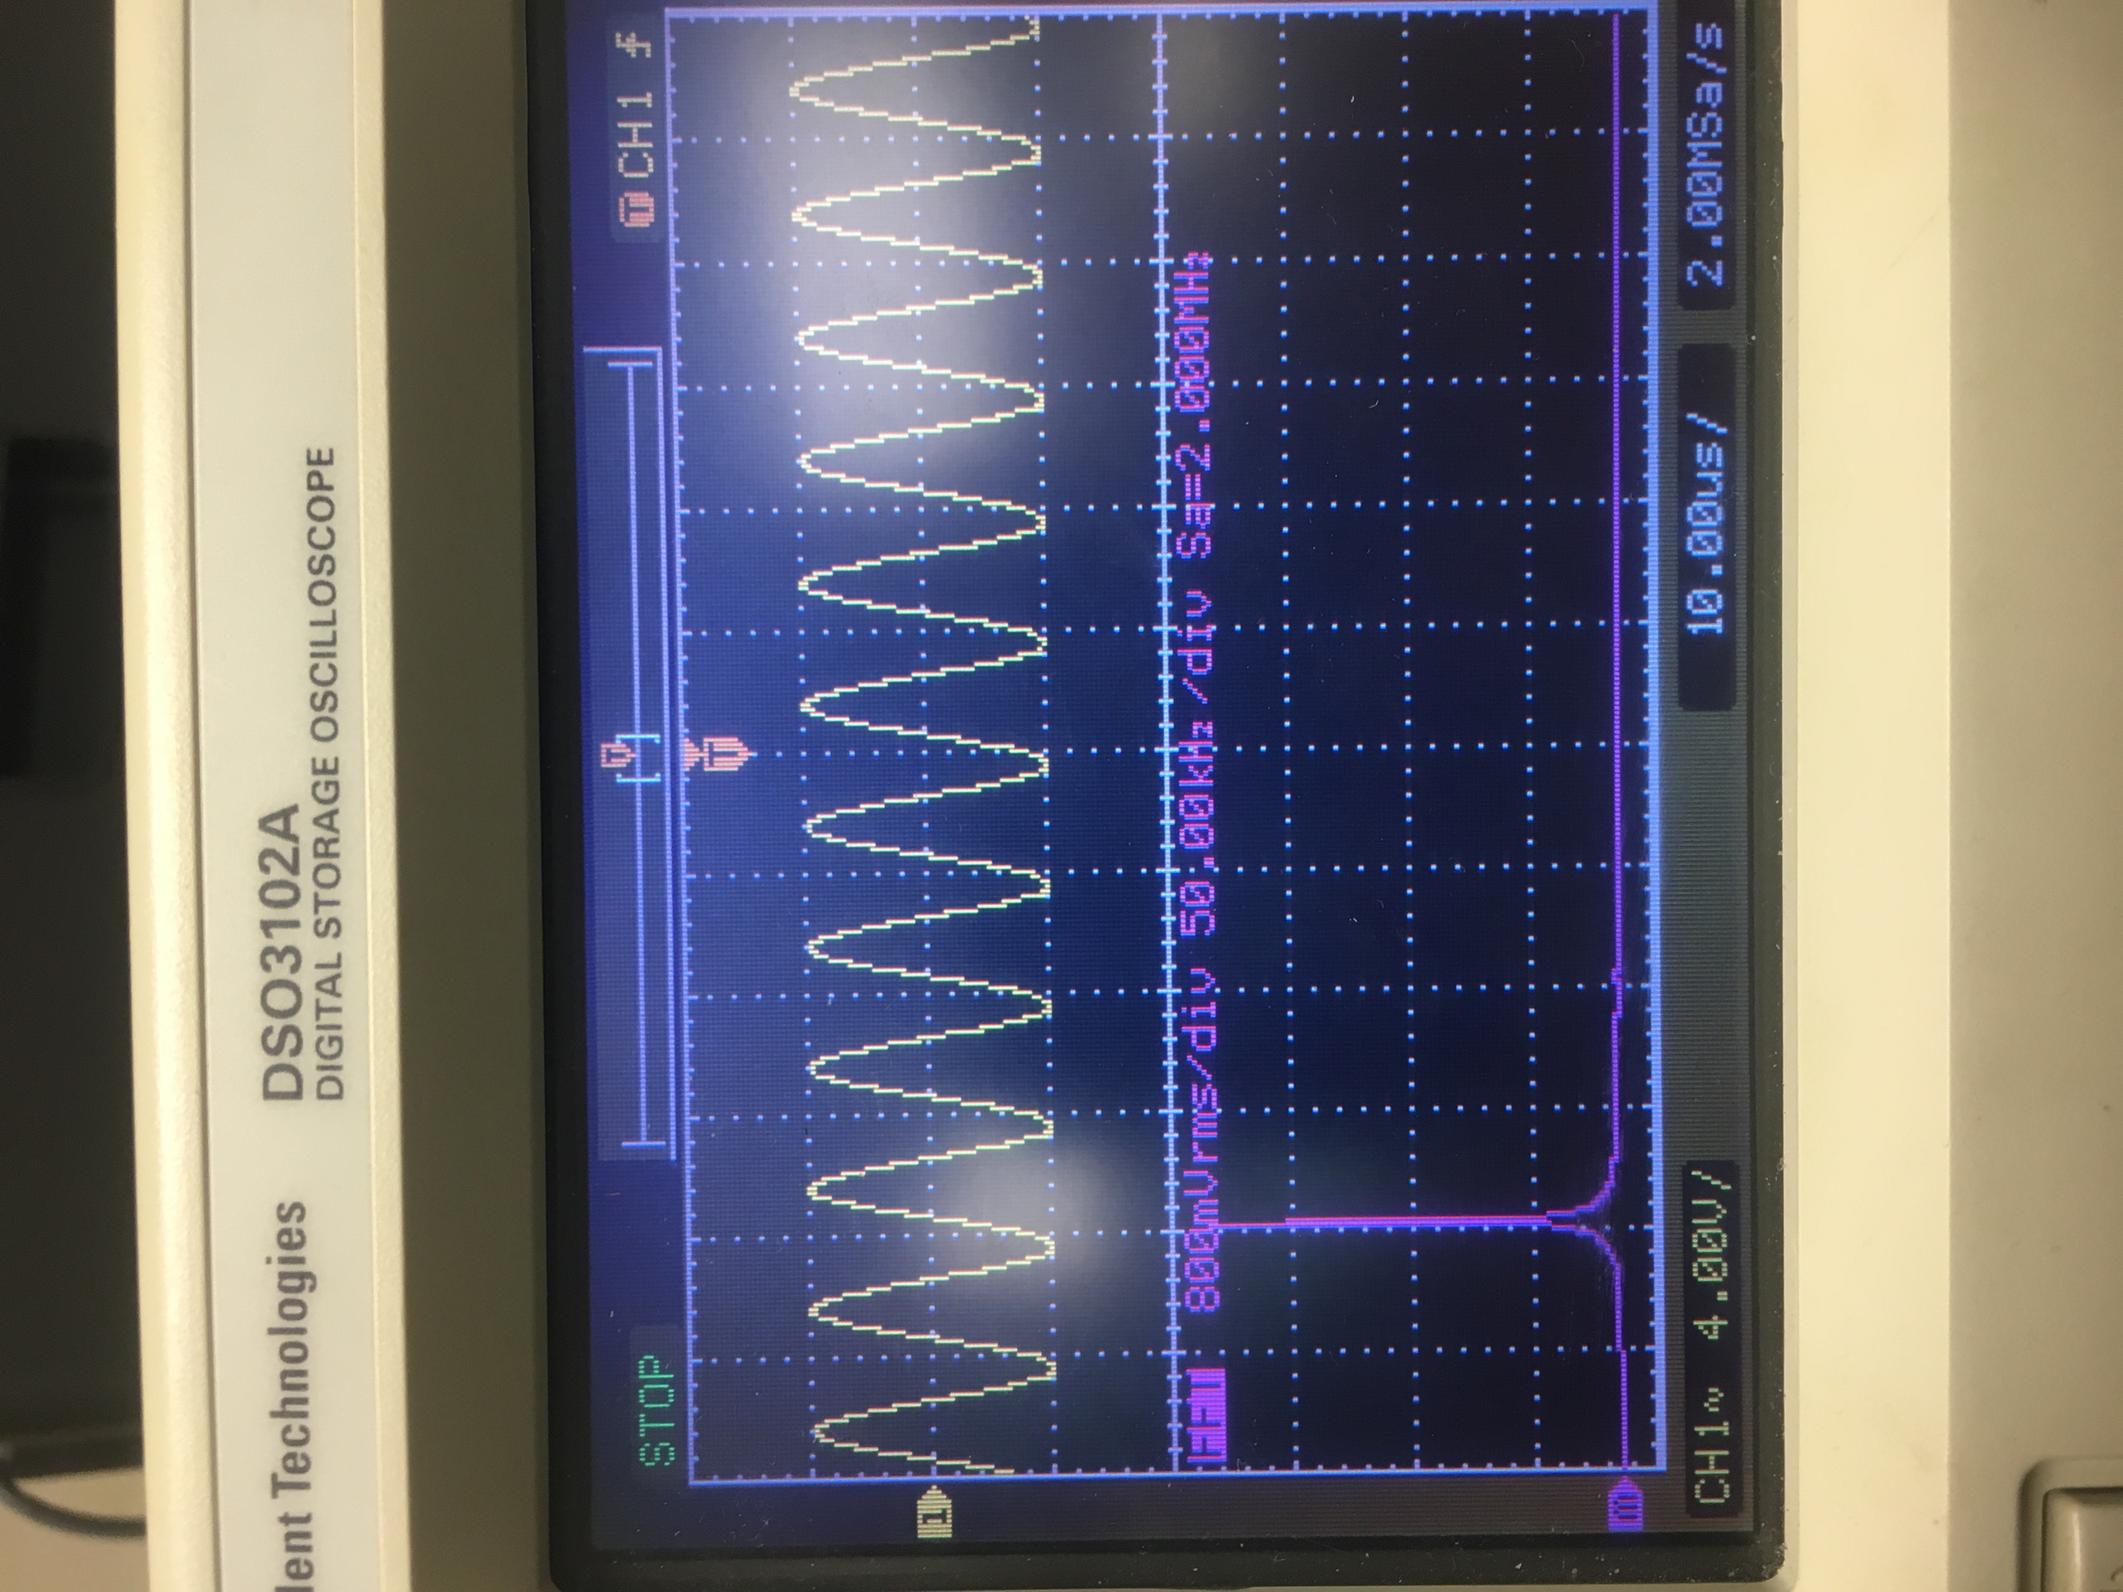

# Run 2:

* Generate a square wave with an amplitude of $2 V$ and period of $T=0.01 ms$. Observe the signal in the oscilloscope screen.
* Observe its spectrum on the spectrum analyzer screen. Why is it different from Run 1?
* What is the fundament frequency? Why do even frequencies appear?
* Change the pulse width from $T to\frac{T}{2}$. What do you see in the frequency domain and why?

# Run 2 Part 1:

* We generated a square wave with an amplitude of $2 V$ and period of $T=0.01 ms$ here.
* The fundamental frequency is $100 KHz$.

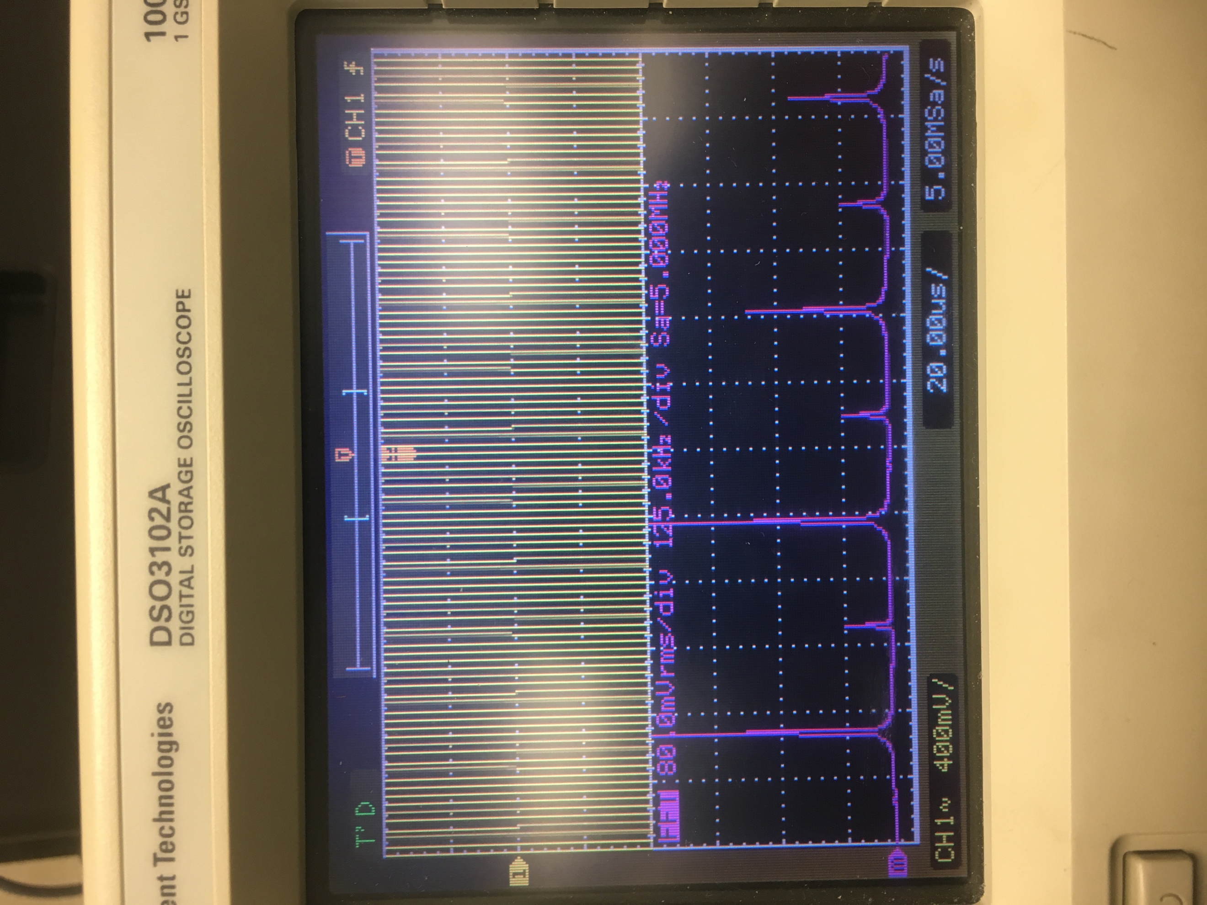

# Run 2 Part 2:

* Change the pulse width from $T to\frac{T}{2}$. What do you see in the frequency domain and why?
* We see that there are no even harmonics.

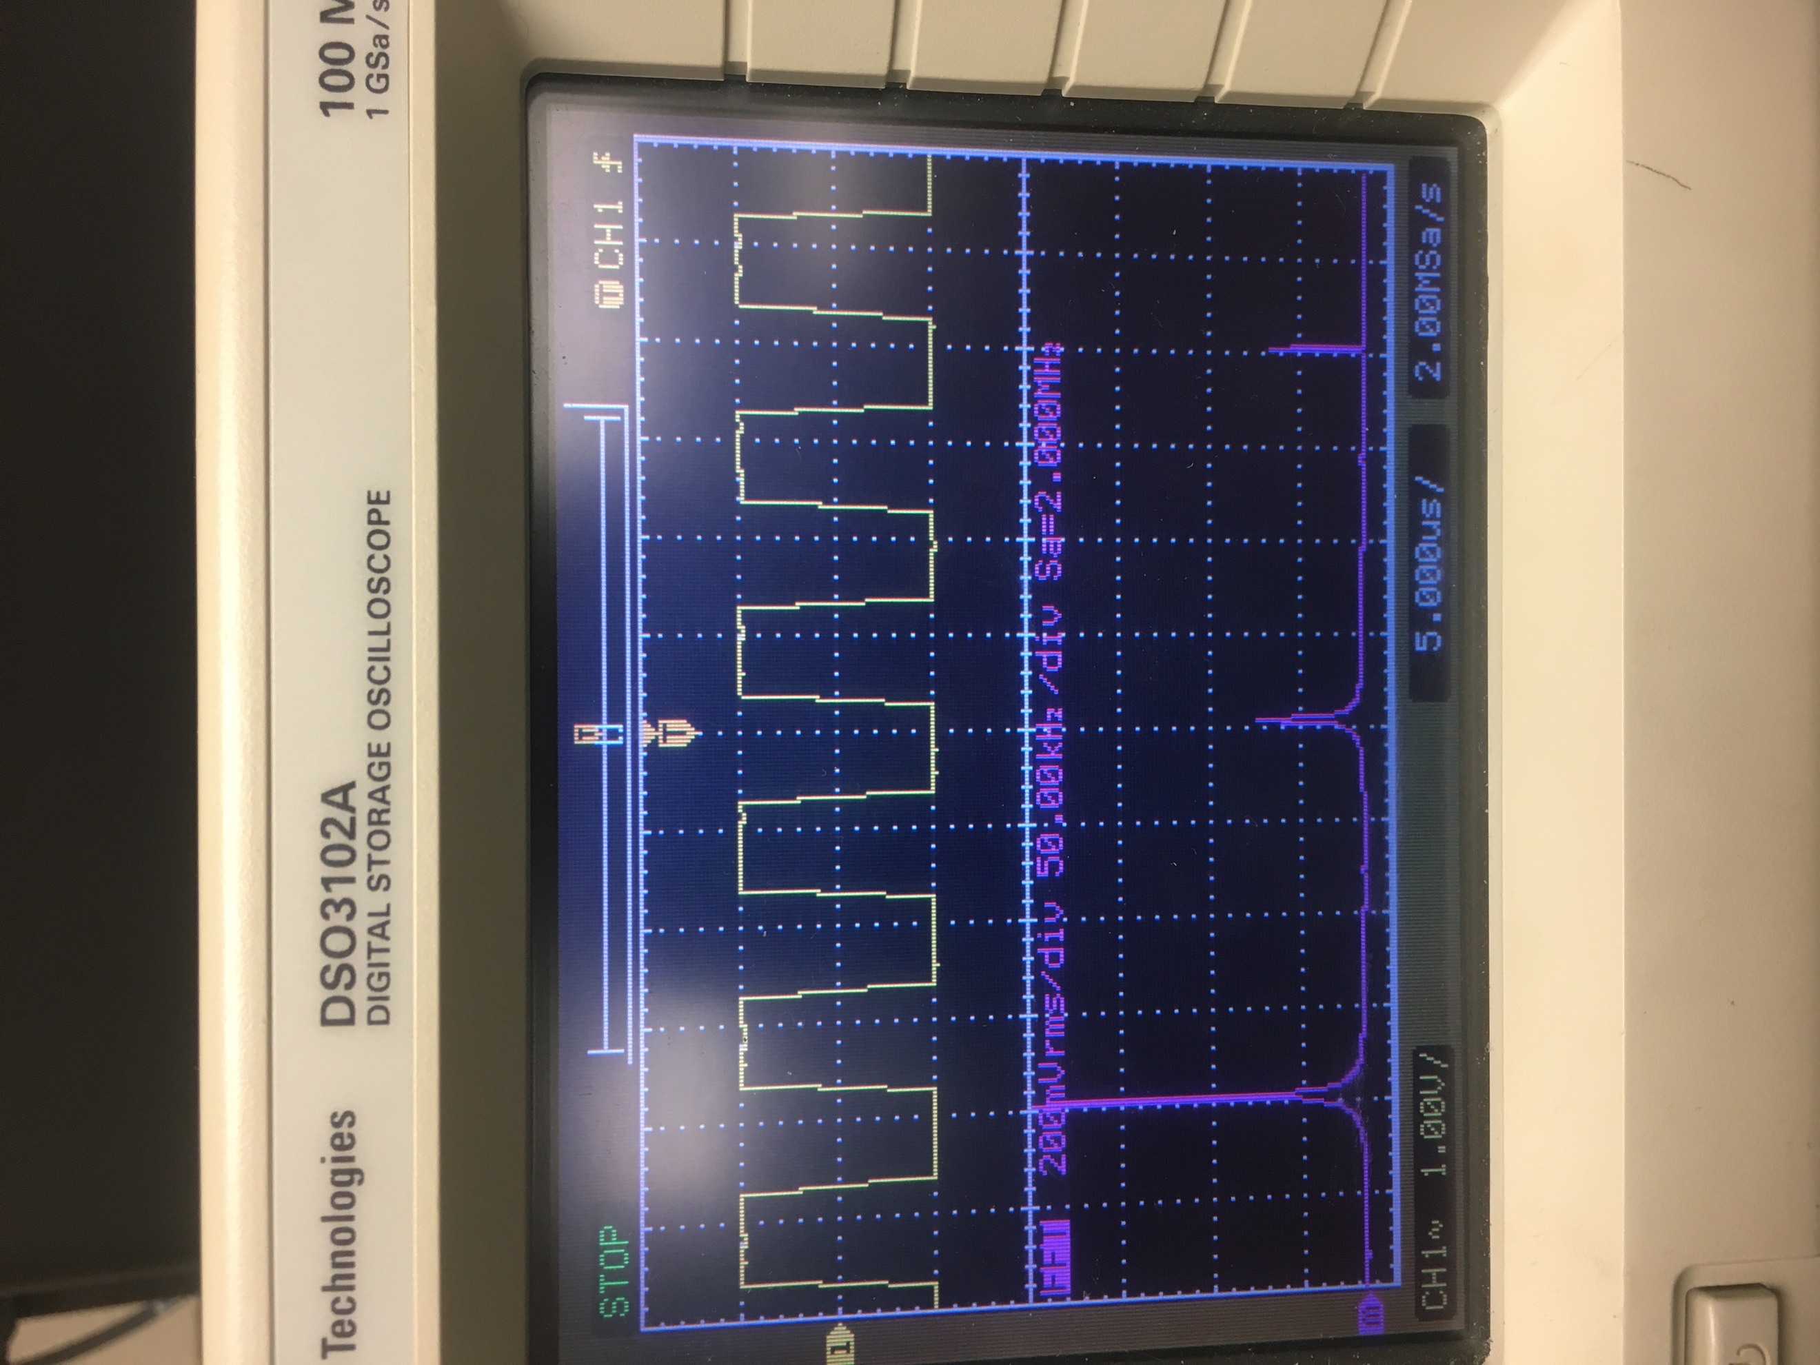

# Run 3:

* Generate a sawtooth signal with the same frequency and amplitude as Run 2
* Observe the signal on both the oscilloscope and analyzer screens.
* Explain what you see.

# Run 3 Part 1:

* We generated the sawtooth signal with the same frequency and amplitude as Run 2, shown below.
* For the spectrum, we see that the sawtooth wave has all harmonics (even and odd).

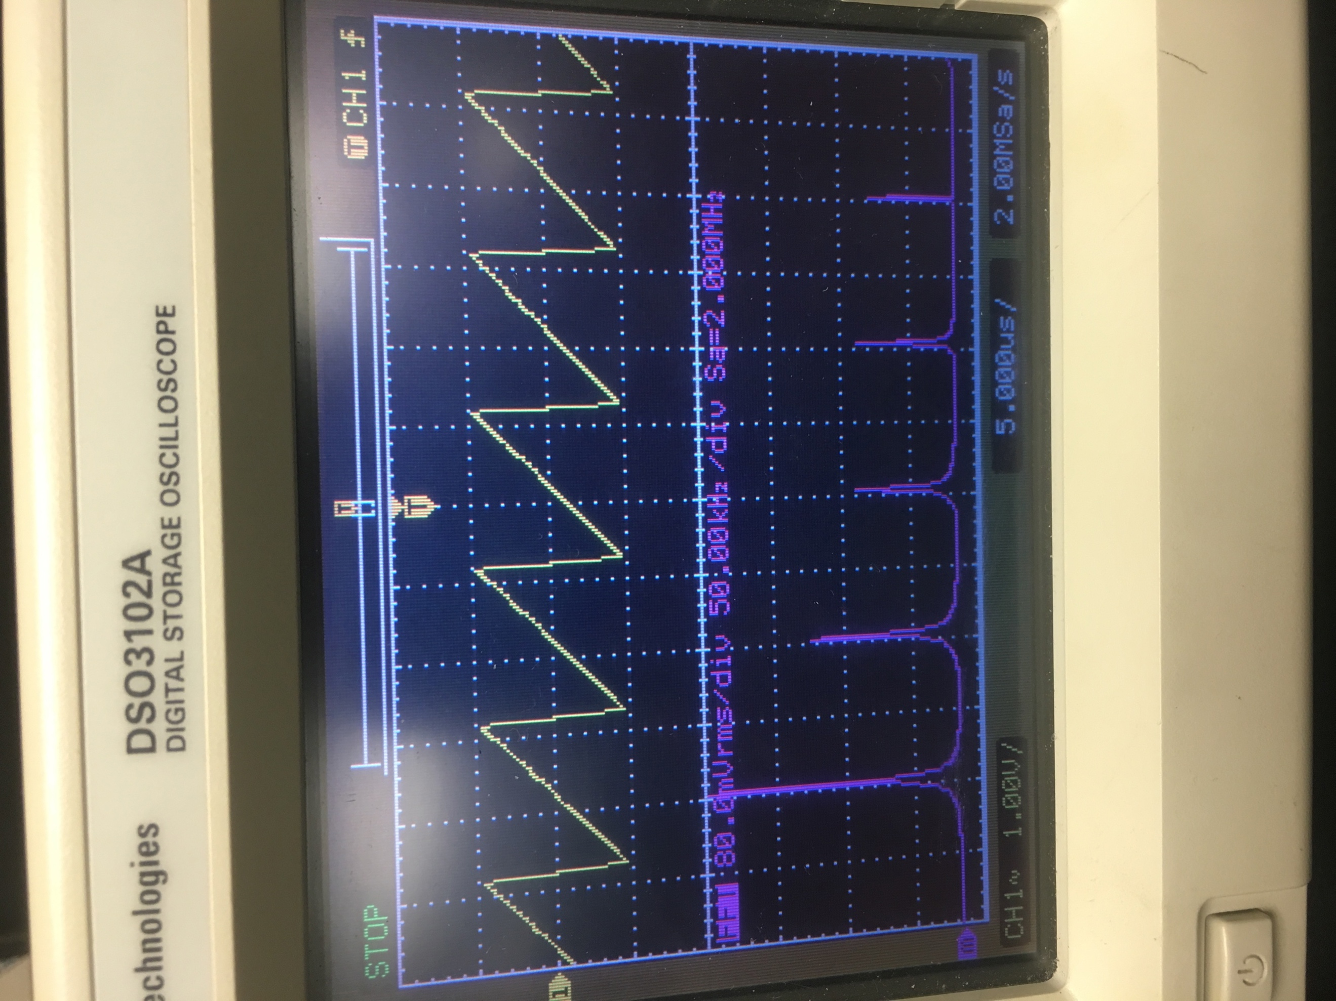

# Conclusion:

* We were able to show the differences in spectrum across the three wave types. We illustrate the effect that amplitude and frequency have on sinusoids, pulse width on square waves, and we discover that the sawtooth signal contains all harmonics (even and odd).